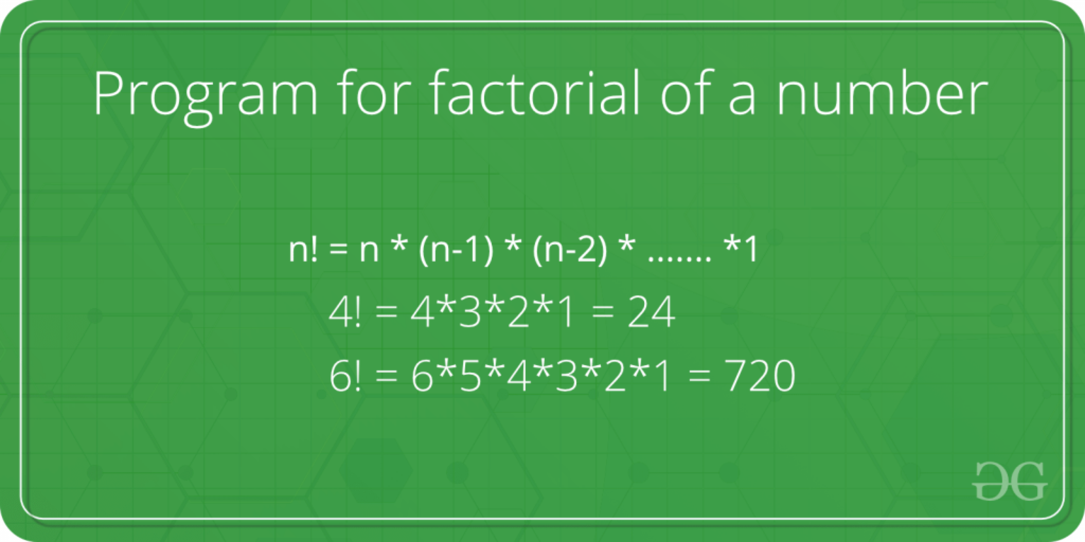

**https://replit.com/@rohitbhardwaj/Recursion-Problems#Factorial.java**